**Amrita Immersion Program Batch 03**

## **Project Statement-V**

Worker Posture and Location Tracking in Mining Operations

**Sensors:** MPU6500 (1), GPS (1)

**Problem Description:**

Safety in mining depends on real-time worker tracking. MPU6500 motion

sensors and GPS tracking, movement and location. Data is uploaded to the cloud for ML-

based anomaly detection, such as irregular motion or falls. Analytics tools provide

heatmaps of worker activity zones, posture trends, and incident patterns. The system

supports quick emergency response and continuous safety improvement through data-

driven insights.

**Stage I : Brainstorming**

**Challenges :** Mining environments pose several challenges for posture and location tracking systems. GPS becomes unreliable underground, necessitating alternatives like UWB or BLE for accurate positioning. Sensor drift due to equipment vibration, device durability, and battery longevity are also concerns. Additionally, ensuring worker privacy and minimizing false alarms is crucial to gaining trust and making the system usable in real-world operations.

**Opportunity:** Despite these challenges, the system offers major safety and efficiency benefits. Fall detection can enable quick emergency responses, while fatigue monitoring can reduce accidents through proactive sleep. Heatmaps and posture trend analysis help identify risk zones and prevent long-term injuries. Anomaly detection and proximity alerts further enhance safety by flagging unusual behavior and keeping workers out of danger zones.

**Ideas:** To implement this effectively, key ideas include integrating UWB/BLE for indoor positioning, adding barometers for altitude tracking, and using ML models to classify posture, estimate fatigue, and identify risk areas. Edge computing ensures real-time alerts even without the internet, and a centralized dashboard gives supervisors a live overview of worker status and safety risks.

**Stage II: Abstract**Worker safety is a major challenge in mining areas. This project aims to enhance safety using real-time posture and location tracking. An MPU6500 motion sensor monitors body movements, while a GPS module tracks location. Abnormal activities like falls or lack of motion are detected and sent to the cloud. Machine learning analyzes data to identify patterns, highlight risky zones, and trigger alerts, ensuring faster emergency response and long-term safety improvements.

**Stage III & IV: Questionaries And Resources**

1. What are the biggest safety challenges your mining site currently faces?
   1. Common challenges include poor visibility, equipment-related hazards, fall risks, communication issues, and difficulty in quickly locating injured workers in large or underground areas.
2. How do you currently keep track of workers' locations during their shifts?
   1. Most sites rely on manual check-ins, shift logs, and occasional radio communication. Some use RFID or basic location tracking, but real-time tracking is rare.
3. Have you faced any incidents where workers were lost or unreachable?
   1. Yes. In many mining sites, there have been cases where workers were unreachable due to being in remote or communication-dead zones, especially underground.
4. How quickly are you able to respond to accidents or falls when they occur?
   1. Response time can vary. In open areas, it's usually fast, but in underground or isolated sections, locating the person and reaching them often causes delays.
5. What delays or gaps exist in your current emergency response process?
   1. Key delays include difficulty in identifying the precise location of the incident, communication breakdowns, and navigating through complex mine layouts.
6. Do you think real-time posture monitoring could reduce such incidents?
   1. Yes, posture monitoring could help detect falls, signs of fatigue, or unsafe behavior early, allowing for preventive action or immediate alerts during emergencies.
7. Frequent emergencies occurring in areas?
   1. Accidents tend to occur more in deep shafts, tunnel intersections, areas with moving equipment, slopes, and poorly lit or ventilated sections of the mine.
8. Are there any blind spots or areas where GPS or communication is poor?
   1. Yes, most underground zones are out of GPS range, and wireless communication (Wi-Fi, GSM, BLE) often struggles without infrastructure like repeaters or mesh networks.
9. How do you usually respond to emergencies in confined or deep mining areas?
   1. Typically, response involves radio communication, manual searching by nearby teams, and coordination with safety officers. The process can be time-consuming and risky.
10. Do you think musculoskeletal injuries due to poor posture are a problem in your operations?
    1. Yes, long shifts involving repetitive, awkward, or strenuous postures often lead to chronic back pain, joint issues, and fatigue among workers.
11. Have you tried using wearable technology for worker safety?
    1. In most cases, no advanced wearables are in regular use. Some sites may use ID badges or smart helmets, but full-body posture tracking wearables are rare.
12. Are you currently using any tracking systems (RFID, GPS, BLE, etc.)? If yes, what are their limitations?
    1. RFID is used at checkpoints but lacks real-time tracking. GPS is ineffective underground. BLE offers promise but requires a network of beacons that may not yet be deployed.
13. What concerns do you have about using wearables in tough environments like mines (e.g., dust, water, temperature)?
    1. Main concerns include durability (resistance to dust, heat, water), comfort, interference with daily tasks, battery life, and whether the device can survive rugged usage.

**Stage V : Idea Layout**

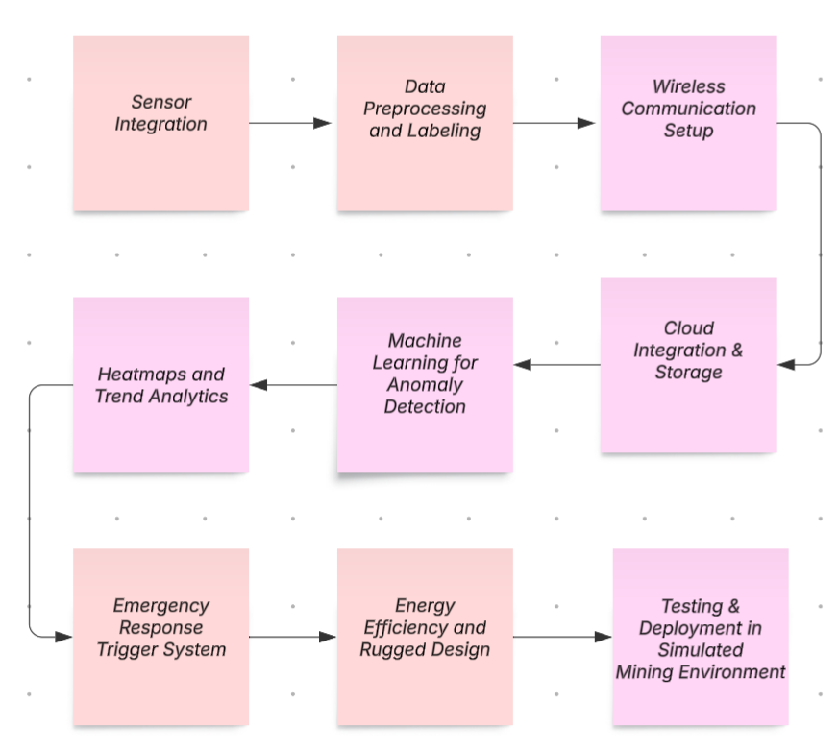

[**https://lucid.app/lucidspark/bcd9cbde-8369-4111-a4c2-c63816db2698/edit?view_items=3z0H_xR6DQz1&invitationId=inv_a960248c-adf2-421c-8ccb-d213e69d8c60**](https://lucid.app/lucidspark/bcd9cbde-8369-4111-a4c2-c63816db2698/edit?view_items=3z0H_xR6DQz1&invitationId=inv_a960248c-adf2-421c-8ccb-d213e69d8c60)

**Stage VI: Design of Modules (Phased Manner – Workforce Identification)**

The overall solution is broken down into well-defined, manageable modules for structured development. For this project, the modules include:

Sensing Module – integration of MPU6500 for posture and motion tracking

Location Module – GPS for surface tracking and BLE/UWB alternatives for underground

Edge Computing Unit – real-time area analysis and alert system (Pi Pico W)

Cloud and Dashboard Module – central monitoring, ML-based analytics, and heatmaps

Workforce and roles are identified for each module such as sensor integration, embedded system development, ML model training, and power BI for the dashboard.

**Stage VII: Reflection Checklist**

The reflection checklist confirms that the project effectively meets the problem description across all six stages. It addresses key challenges like fall detection, GPS limitations in underground mining, and the need for real-time alerts. The design includes posture tracking with MPU6500, alternative location tracking using BLE/UWB, and a dashboard for monitoring. Resources, timelines, and risks were well-planned, and the system was tested for reliability, durability, and accurate anomaly detection—ensuring a practical and robust solution for improving worker safety.

**Stage VIII: Resources Identification (Identification of Requirements)**

All hardware, software, and human resources needed for each module are identified. This includes:

Sensors: MPU6500, GPS modules, barometers

Computing Devices: Microcontrollers (e.g., ESP32), edge processing units

Connectivity: BLE/UWB modules, Wi-Fi modules

Cloud Platform: For data upload, analysis, and dashboard deployment

Personnel: Embedded developers, ML engineers, UI/UX designers, safety consultants

A budget estimation and procurement plan are also formed.

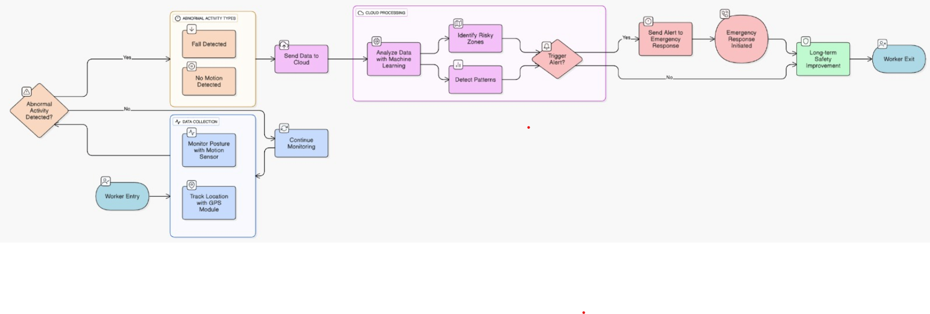

**Stage IX: Planning (Project Schedule)**

A clear timeline is developed outlining start and end dates for each phase of the project. Key milestones include:

* Sensor integration and baseline data collection
* Edge alert system and anomaly detection
* Dashboard prototype and data visualization
* System testing and refinement

Dependencies, buffer time, and deliverables are clearly charted. Tools like Gantt charts or project tracking software may be used.

**Stage X: Re-Design (Checklist)**

A final checklist-driven review is conducted to verify technical, logistical, and ethical feasibility:

Is underground tracking resolved through UWB/BLE?

Are false positives from posture classification minimized?

Is edge computing reliable in offline conditions?

Are all emergency use cases covered?

Is the design durable for mining conditions (dust, moisture, ruggedness)?

Based on this checklist, minor redesigns or refinements are made before transitioning to the prototyping phase.

**Stage XI: Execution Framework (Modules)**

The header section of the Power BI dashboard provides a quick overview of critical global KPIs using visually distinct cards or summary tiles. These include **Total Workers Tracked**, showing the number of active workers monitored in real time; **Restricted Zone Entries**, indicating the count of GPS boundary violations based on location data; and **Falls Detected**, which highlights posture-triggered alerts using accelerometer (accZ) thresholds. Additionally, the **Devices Offline** KPI reflects the number of sensors that are currently not responding, helping identify connectivity or hardware issues. Lastly, the **Safety Score** provides an ML-based metric indicating overall site safety by measuring anomaly percentages or risk levels, enabling rapid decision-making.

The Power BI dashboard integrates multiple data sources to provide real-time analytics and actionable insights. GPS and MPU sensor data—used for tracking location, motion, and posture—are pulled from the ThingSpeak API or CSV dumps. Alerts, such as fall detection or entry into restricted zones, are sourced from cloud logs or machine learning output. Worker ID mapping, essential for associating sensor data with individuals, is fetched from Excel sheets, SQL databases, or Firebase. Restricted zones are defined through static Excel or JSON files, enabling location-based alerts. Device status features like battery level, signal strength, and last update time are retrieved from MQTT broker logs or APIs, ensuring system reliability and monitoring.